**SSN College of Engineering**

UCS1611- Internet Programming Lab

Permission and Request Online System

**Members**:

Abhishek Narayan

Advaith N Narayanan

A Anirudh

Digant Mehul Gandhi

**Contents**

1. Problem Statement 2

2. Software Requirement Specification 4

2.1. Overall Description 5

2.2. Specific Requirements …6

2.2.1. Functionality………………………………………………………………………….…6

2.2.2. Usability…………………………………………………………………………………6

2.2.3. Reliability….…………………………………………………………………………….6

2.2.4. Performance..........………………………………………………………………………6

2.2.5. Design Constraints………………………………………………………………………7

2.2.6. Interfaces……..………………………………………………………………………….7

3. Use Case Model – UML Use Case Diagram 8

3.1. Use Case Description 8

3.2. Use Case Diagrams 10

## **1. Problem Statement**

**Background**

SSN College of Engineering comprises over 4000 students and several hundred faculty, staff, and admin. SSN offers students an option to be a day scholar or a hosteller. With many students opting to be hostellers, the process of getting Leave-form from hostel wardens becomes tedious, specifically during festivals, long weekends and during exam holidays.

Likewise, during events or competitions, faculty members need to give permission to several students for OD and this process is tedious and time consuming for faculty and students. In case of emergency, if the faculty is unavailable, it is very difficult for the student to get permission to leave the college.

The process for collecting documents such as 10th and/or 12th certificates is lengthy where students do not have a clear idea on who to meet or where to go. This makes the process of getting the required documents cumbersome. Also, there is the issue of the faculty being free and the documents being available to hand over to the student, else the student is asked to visit some other day to collect the same. Thus, it makes it hard for both the faculty and the student.

Students find it hard to contact any faculty/warden when they have some general queries or doubts. Either they do not know who to contact or they do not know when they would be free or even where they would be. Mails sent using the official SSN email id often go into spam, making the process even challenging.

We believe that the extensive time and effort that goes into requesting for hostel leave-forms, OD permission, Official documents among others, can be simplified and made more convenient with the help of a well-designed and effective web application that provides an interface to students for requesting permission and documents from hostel wardens, professors, and other office members. Similarly, the hostel wardens and professors can choose to accept/reject the students requests on a case-by-case basis without any paperwork, just by a single click.

**Introduction**

The process of requesting and receiving permission from Professors/Hostel wardens is currently performed manually where the student needs to personally find the authority in-charge and request for permission. For instance, during long weekends, hundreds of hostellers need to personally seek out the Hostel warden to request for hostel leave form. Due to a large number of students requesting permission in person, the process is very tedious and inefficient. Similarly, in order to get OD permission, students need to request Professors by visiting the staff room. In case the Professor is taking class or not in the staff room, or in case there are many students participating in an event requiring OD, the process yet again becomes tedious for both the teachers and the students. Moreover, the Professors/Hostel wardens need to verify the students' reason for requesting permission to identify legitimate requests and give permission to only those students with legitimate reasons. This takes time and further, if the number of requests is more, becomes harder to track which students received permission.

We have decided to investigate the use of a Permission and Request Online System. This system would be  used by students, professors and hostel wardens of  SSN College of Engineering  to  check requests raised by students with any support documents, and decide to accept or reject the request.. The purpose of this document is     to analyze and elaborate on the high-level needs  and features of the Permission and Request Online System**.** The details of what all are the needs of the Permission and Request Online Systemand if it fulfills these needs are detailed in the use-case and supplementary specifications.

The PROS helps students and professors with issues involving permission and other requests.

The students face issues in the following areas:

* Acquiring permission to leave the college using hostel leave forms for hostellers and for day scholars to leave early. Female students need to apply leave forms one day prior.
* Acquiring OD from professors during college hours especially during events/competitions involves many students queueing, resulting in long wait times and inconvenience.
* Acquiring permission for leave of absence from professors without interrupting classes in case of an emergency situations requiring immediate leave.
* Acquiring information on where to collect documents such as 10th,12th certificates for passports, etc. and Transcripts for intern and other off campus opportunities
* Acquiring information on general aspects such as where to go for a particular class, when to come for getting record signed, whom to contact for in case of any events among others.

The professors and hostel wardens face issues in the following areas:

* Inconvenience as they may not be available and/or free when the student requests OD/Leave-form.
* Inconvenience to keep track of the students who are taking OD/leave in case of events/competitions involving multiple students.
* Occasions like public holidays see many hostellers waiting in line for hostel wardens and this long-drawn process in inconvenient for wardens.
* Staffs/faculties may not be free when student arrives to ask for documents, etc. They must reschedule quickly considering their hectic schedule
* Professors face issues when students have genuine queries, but they don’t have the time or answer at that moment to answer them. Sometimes they might get the answer/time and find it hard to contact the student who asked the question.

**Our Methodology**

We propose to create a log-in portal for students and faculty/hostel admins entering their information; each having their own interfaces.

* **Student Interface**

Students have a list of options to choose from a fixed set of request/permission that they can ask for. They can upload necessary information(medical certificate, participation proof, reasons to leave hostel) and send it to the appropriate authority for approval. If the student request is approved, he/she receives a message with necessary details and it can be verified for authenticity while leaving the college by simply showing the id card

* **Professor/Hostel Warden Interface**

The professor/warden will receive a notification of the request raised from student and they can go through the uploaded information and chat with the student before accepting/rejecting the request.

* **Requesting of Original Documents**

The student selects the request for the document through the student interface as mentioned above. Depending on the document type, the receivers address is automatically added(CSE department/ Exam cell for transcripts and CDC/SSN office for 10th and 12th documents).Once the students describe the reason and sends the request, he/she waits for reply from the faculty. Meanwhile in the faculty interface, they can accept/deny the request and once they accept, they can notify the time and place for the student to collect the necessary documents, thus making it easier for both the parties.

* **Other general queries**

Apart from the above mentioned, there are a variety of queries that the student may have. The students once clicking on the other queries, selects the receivers address and types his query in the box allocated to it. After clicking send, the request goes to the pending list. Once the request has been answered to, the student gets a notification, and he/she can find their answers there.

* **Authenticity Rating:**

There is a authentication rating for the professors and faculties where they can give ratings of the students behaviour and conduct in the particular request that he/she asked. This will be made public and displayed along with the student’s name the next time he/she asks for a permission.

## **2. Software Requirement Specification**

#### The Software Requirements Specification captures all the requirements in a single document. The Permission and Request Online System that is to be developed is supposed to have the following features.

#### The system provides the students with the ability to raise requests and professors and hostel wardens to view and choose to accept or decline the requests.

#### The system provides logon facility to the users- students, professors and hostel wardens.

#### The system provides the users with the option to check their account and/or change their options like password of the account whenever needed all through the day.

#### The system allows the users to raise requests 24 hours a day and all through the semester.

#### The system lets the professors and hostel wardens to check which students have raised requests and view supporting documents and then decide to accept or decline requests.

#### The system updates the students' request history as and when their requests get accepted or declined.

#### The system also has an option to add new students to the system as and when they get admitted into the college.

The features that are described in this document are used in the future phases of the software development cycle. The features described here meet the needs of all the users. The success criteria for the system is based on the level up to which the features described in this document are implemented in the system.

## **2.1. Overall Description**

**Product Perspective**

The Permission and Request Online System (PROS) is a web application that will be used by students, faculty members, hostel warden and other staff members of SSN College of Engineering to increase the efficiency of the current approach used in acquiring permissions and requests. The Permission and Request Online System benefits students and staff greatly by decreasing the time and effort needed to request and grant permission. The PROS provides multiple options for the students to choose their requests ranging from leave forms for hostellers, On Duty permissions, Early leave permissions for day scholars and other general requests. The professors/warden/staffs can choose to accept or reject the request with just a single click.

The application to be developed has interactions with Students, faculty members and hostel wardens.The product has to interact with the Internet.

**Product Functions**

The Permission and Request Online System(PROS) provides various permissions and requests. The Product functions are more or less the same as described in the product perspective. The functions of the system include the system providing different type of services based on the type of users [Student/Faculty].

* Provisions for the students to ask for permission if all the other required rules hold good.
* The member is given a provision to check his account information and change the account information any time in the given valid period.
* The members are provided with the various permissions as a list and can choose any one among them
* The faculty is prompted with the request along with details of the student's permission history.
* The faculty is provided with interfaces to accept/reject and also chat with the user before giving permission.
* The students when receives the permission, a QR code is generated, which can be used by the students
* The system uses the University information security requirements to provide the login facility to the users.

**User characteristics**

The users of the system are students, faculties of the university and the administrators who maintain the system. The students and the faculties are assumed to have basic knowledge of the computers and Internet browsing. The administrators of the system should have more knowledge of the internals of the system and are able to rectify the small problems that may arise due to disk crashes, power failures and other catastrophes to maintain the system. The proper user interface, users manual, online help and the guide to install and maintain the system must be sufficient to educate the users on how to use the system without any problems.

### **Constraints**

* + The information of all the users must be stored in a database that is accessible by the system.
  + The university information security system must be compatible with Internet applications.
  + The Permission and Request system runs all 24 hours a day.
  + The users will be able access the Permission and Request System from any computer that has Internet browsing capabilities and an Internet connection.
  + The users must have their correct usernames and passwords to enter into the System

### **Assumptions and dependencies**

* + The users have sufficient knowledge of computers.
  + The College/University computer should have Internet connection and Internet server capabilities.
  + The users know the English language, as the user interface will be provided in English
  + The product can access the university student database

## **2.2. Specific Requirements**

## This section describes in detail all the functional requirements.

#### 2.2.1. Functionality

#### Login Capabilities

#### The system shall provide the students and the faculties with login capabilities.

#### Mobile Devices

#### The Permission and Requests System is also supported on mobile devices such as cell phones.

#### 2.2.2. Usability

* + - The system shall allow the users to access the system from the Internet using HTML or its derivative technologies. The system uses a web browser as an interface.
    - Since all users are familiar with the general usage of browsers, no specific training is required.
    - The system is user friendly and self-explanatory.
    - The system is secured to avoid forging

#### 2.2.3. Reliability

#### The system has to be very reliable due to the importance of data and the damages incorrect or incomplete data can do.

#### Availability

#### The system is available 100% for the user and is used 24 hrs a day and 365 days a year. The system shall be operational 24 hours a day and 7 days a week.

#### Mean Time Between Failures (MTBF)

#### The system will be developed in such a way that it may fail once in three months.

#### Mean Time to Repair (MTTR)

#### Even if the system fails, the system will be recovered back up within an hour or less.

#### Accuracy

#### The accuracy of the system is limited by the accuracy of the speed at which the students and the faculties use the system.

#### Maximum Bugs or Defect Rate

#### Not specified.

#### Access Reliability

#### The system shall provide 100% access reliability.

#### 2.2.4. Performance

#### Response Time

#### The Splash Page or Information page should be able to be downloaded within a minute using a 56K modem. The information is refreshed every two minutes. The access time for a mobile device should be less than a minute. The system shall respond to the member in not less than two seconds from the time of the request submission. The system shall be allowed to take more time when doing large processing jobs.

* **Administrator/Faculty Response**

The system shall take as less time as possible to provide service to the administrator or the faculty.

* **Throughput**

The number of transactions is directly dependent on the number of users, the users may be the Administrator, Faculties and also the students of the college for asking permissions, making requests, and requesting transcripts.

* **Capacity**

The system is capable of handling 100 users at a time.

#### 2.2.5. Design Constraints

#### Software Language Used

#### The languages that shall be used for coding the Permission and Request System are Java Servlets, Java Server Pages (JSP), HTML and JavaScript. For working on the coding phase of the Permission and Request System, the Internet Information Services (IIS) Server needs to be installed.

* **Development Tools**

Will make use of the available Java Development Tool kits for working with Java Server Pages. Also will make use of the online references available for developing programs in JavaScript and HTML.

* **Class Libraries**

Will make use of the existing Java libraries available for JSP and Servlets.

#### 2.2.6. Interfaces

#### User Interfaces

#### Will make use of the existing Web Browsers such as Microsoft Internet Explorer, Mozilla Firefox or Google Chrome.

#### Sample Interface:

#### For sample interface, click on the below links and explore different tabs present

#### <https://abhisheknarayan190.wixsite.com/pros> ->Student Interface

#### <https://abhisheknarayan190.wixsite.com/my-site-2> ->Faculty Interface

* Hardware Interfaces

The existing Local Area Network (LAN) will be used for collecting data from the users and also for updating the database of the system.

* Software Interfaces

A Scanner will be used with the server to prevent duplicacy of the system.

* Communications Interfaces

The Permission and Requests System will be connected to the World Wide Web.

## **3. Use Case Model – UML Use Case Diagram**

**3.1. Use Case Description**

**Scope:** Permission and Request Online System

**Primary Actor:** Student

**Stakeholders and Interests:**

* **Student**

Wants fast and easy grant of permissions, as current procedure is too tedious. Wants an easy to use User Interface to enter their reason and other information for asking permission. Wants to be able to upload supporting documents. Wants to be able to download granted permission for any verification.

* **Faculty**

Wants easily visible information of students requesting for permissions. Wants supporting proof of request. Wants to be able to check students' request history and rating. Wants to be able to Accept or Decline requests of one or more than one student. Wants to be able to give rating to the student based on the request. Wants to be able to chat with student incase more information is needed.

* **Database**

Wants to authenticate and remove redundancy in student and faculty login information. Wants to accurately record all incoming requests along with the supporting documents. Wants to track status of Request. Wants to maintain request history and student rating based on request history. Wants automatic and fast update of request information

* **College**

Wants to collect details of each student and assess student behavior

**Preconditions:** The student is identified and authenticated

**Success Guarantee (or Postconditions):** Requests are saved. Rating is calculated. Database is Updated. Permissions are recorded along with the priority ones. QR Code is generated.

**Main Success Scenario (or Basic Flow):**

1. Student visits the site to request for permissions

2. Student logs in or register into the system

3. Database identifies the student

4. Students choose a permission out of a list of permissions.

5. System asks for student to enter the reason and upload supporting document

6. Faculty gets notification of request

7. Faculty views the request and supporting information and chats with student for validation

8. Faculty accepts or declines the request and gives rating to the student

9. Student receives the notification of request decision along with the QR code

10. Student logs off the system

**Extensions (or Alternate Flows):**

1.At any time, system fails:

To support recovery, and ensure all details and events can be recovered from any step of the scenario.

2.Student enter invalid/forgot login credentials mode:

* System provides the option of entering a registered email address for password reset.
* Student or Faculty reset their old password to a new password by answering the security question
* Student or faculty can search for the mail address and send login link to it

1. If mail Id does not exist:

* System should tell student or faculty to contact administrator

3.Invalid/Not Existing Username is database:

* System signals error and asks student to register and add necessary credentials

4.The permission entered is not wanted

* Student can delete the permission before it gets approved

5. Supporting document exceeds the size limit:

* System restarts the upload service again

6. Timeout is achieved

* The request is turned into a priority request and the notification is sent to the faculty

**Special Requirements:**

1. Touch Screen UI on mobile. Text visible from 1 meter

2. Laptop with touch pad or mouse and keyboard on laptop.

3. Language internationalization on the text displayed

4. QR scanner for verification

**Technology and Data Variations List:**

1. QR verification can be done by using a QR code scanner or or by entering the associated unique ID.
2. The documents uploaded by the students may be in the .docx, .pdf, .jpeg, .png, .tiff, .avi or .mp3 format.
3. The chat between the staff and professor will be encoded in the Unicode character representation standard only.
4. The permission history of each student can be stored in a database. However, it may become necessary to transfer the less recent history of the student to a secondary storage as the number of users on the system increase.

**3.2. Use Case Diagrams**

There are a total of 3 use case diagrams. One denotes the major flow of the System, the other 2 denotes the details of the sub use cases present.

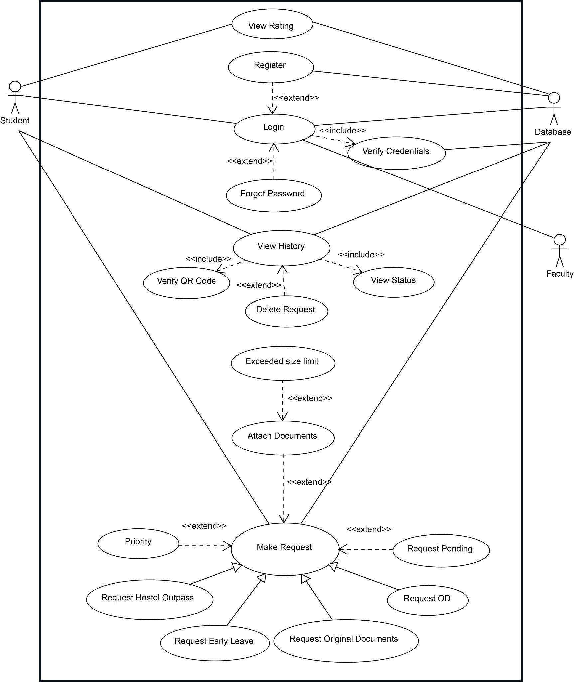**Use Case Diagram 1**

**Use Case Diagram 2**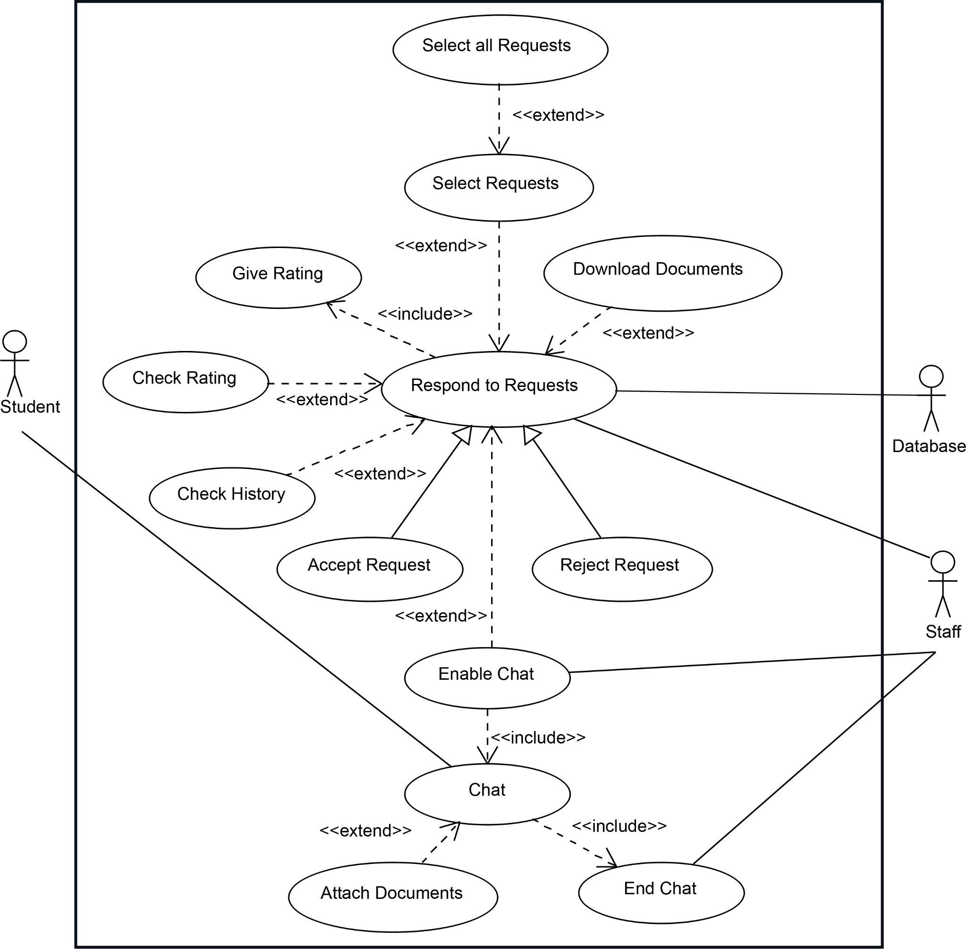

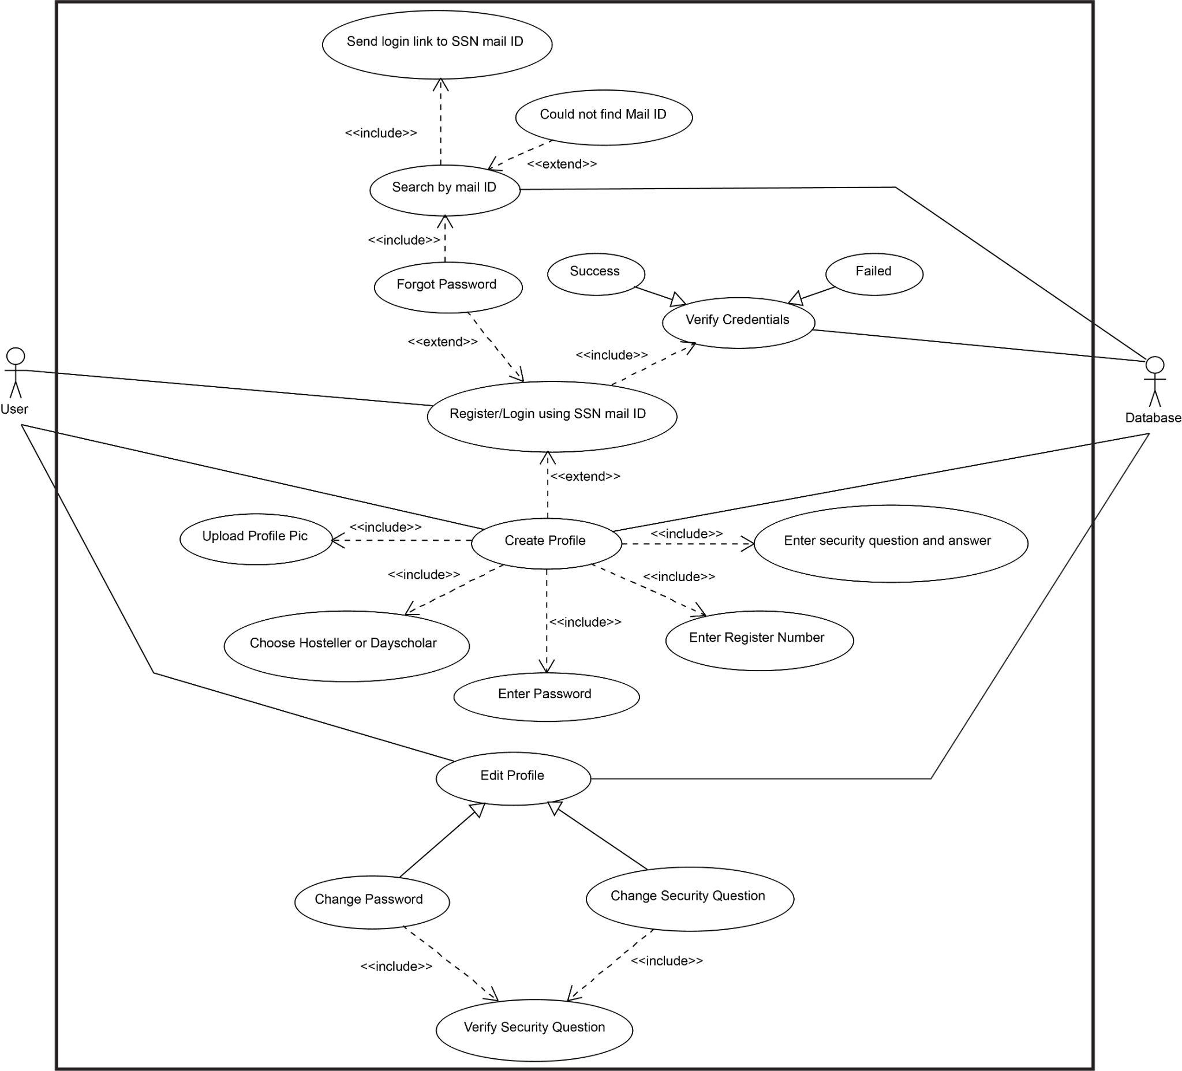**Use Case Diagram 3**